**Unit 2: Working with Objects**

**Topic 2 Lab 2: Partner Programming Challenges!**

| **Name:** |  | | |
| --- | --- | --- | --- |
| **Partner Name:** |  | | |

This is a **pair programming** lab: you and your partner should code together in the **same** Replit project, just like if you were both typing in a shared Google Doc!

| **Setup** |
| --- |
| **Follow the instructions below to create a collaborative Replit for you and your partner.**    Choose **ONE** partner to:   1. Open up the team project. 2. Click:  on the right 3. Click **Add Group**:      1. Click **OK**:      1. Click **Confirm** to allow notifications (if this pop up appears).   After the first partner completes the steps above, the **OTHER** Partner should:   1. Open up the  team project. 2. Click:  on the right 3. Locate and **Join** the group *started by your partner!* Make sure you select the right one (if you accidentally join the wrong group, let Mr. Miller know):     ***Once both partners are in, both partners will be coding alongside each other!*** |

| **Partner Warm Up!**  Create a Cat class (filename: Cat.java) and copy/paste this code:  public class Cat {  private String name;  public Cat(String name) {  this.name = name;  }  public void feed(String food) {  **// write me!**  }  public void introduce() {  **// write me!**  }  }  **1.** Write the feed method to print a statement like *"Yum! ___ loves ___!"* where the cat's name appears in the first blank and the food appears in the second blank.  **Test** your method by making a Cat object in the main method of your Main class, give the Cat a name of "**Fluffy**", then call the feed method, passing in "**tuna**" as the parameter.  The output should be:    **2.** Write the introduce method to print a statement like *"Hello, my name is ___!"* where the cat's name appears in the blank  **Test** your method by calling the introduce method on the same object you created above.  The output should be:    **3.**  **Try** modifying your introduce method to look like this, adding the food to the end of the printed string:    Run your code; what is the error and why does it occur?   |  | | --- |   Notice that the instance variable name can be used in *both* methods, whereas the parameter food can *only be used in the* feed method. What conclusion can you draw about instance variables vs. parameters in terms of which methods can use/access them?   |  | | --- |   Remove the broken code from step 3, then copy/paste your **Cat** code: |
| --- | --- | --- |
|  |

| **Game Time!**  Partner Challenge 1 | | |
| --- | --- | --- |
| **1.** Add a new Game.java file then [copy/paste this incomplete Game class](https://docs.google.com/document/d/1-2eMhplp8rL9CmBYsgLUSd0JfH9rZI8CLLLvUopJxVI/edit?usp=sharing).  **2.** Take a look at the Game class constructor; notice that it has two parameters, and in the body of the constructor’s code, one of the instance variables (score) is set to a default value of 0.  **3**. Your team's task is to complete several missing methods of the Game class, detailed below. Find the place in the Game class where you should complete each task by looking for the specified comment, such as: /* TO BE IMPLEMENTED IN PART A */   1. Complete the missing code for the getPlayers() “getter method” that returns the value of the players instance variable. 2. Add a getScore() “getter” method for the score instance variable. 3. Complete the missing code for the addPlayer() method that increases players by 1; note that this method is void (it has no return value). 4. Add an increaseScore method that has one int parameter (name it “increase”) and increases score the amount of increase; the method should *not* return a value (i.e. make it void). 5. Add an averageScorePerPlayer method that has no parameters and returns the *average score per player* as a double; for example, if players is 4 players and score is 11, this method should return 2.75. 6. Complete the missing code for the isGameOver method so that true gets returned if score is greater than 9, otherwise false is returned.   **4. TESTING!**  Test your Game class by copying/pasting [this code into your Main class' main method](https://docs.google.com/document/d/1DrvIAbpBKvH_vUW8JUC-TQAvE2MiPwaIVd6B4O17B_8/edit?usp=sharing) and running.  **Expected output *Make sure your program output matches the following exactly!***    **5.** Copy/paste your **completed and tested** Game class below: | | |
|  | | |
| **6. Free Style!** Remove and add some different test code in Main; create a new Game object (for example a game of Checkers with 2 players, but do anything you want!), add some players, increment the score a few times, print out the average score, etc. **Try some things out!**  Play around with the code of Game class too. Add or edit existing methods, change methods, test it out. See what you can come up with and what you figure out!  **Copy/paste the test code you added to Main:** | | |
|  | | |
| **Copy/paste your freestyled Game class:** | | |
|  | | |
| Briefly describe what you added, changed, and figured out! |  | |

###### If you and your partner want to, feel free to compare your completed Game class to this sample

**LAB CONTINUES ON NEXT PAGE**

| **Letter Writer!**  Partner Challenge 2 | | |
| --- | --- | --- |
| **1.**  Add a new Letter class to your Replit project, and [**copy/paste this code**](https://docs.google.com/document/d/11CtYAqNAuGQC9fkTF6oyzkQkF9sKXqieaXKMtPei8NM/edit?usp=sharing).  **2.**  Clear out the code in your Main class' main method.  **3.**  In the main method, create a Letter object (name the variable whatever you want), and call *each of the three methods* to print a letter:   * start with the greeting method * then the special message method * then the closing method   **Note:** the Letter class only has a *no-parameter* constructor, so to create a Letter object, you need to do this**:** new Letter()  ***Expected output:***   Let us double check our code | | |
| **4. In the Letter class,** locate /* TO BE IMPLEMENTED IN PART 4 */and add a **new** writeLetter method that, when called, prints the *same* output as calling the three separate methods. It should not return a value. ***Do not*** *just type three identical print statements! Instead, you should* ***call the three methods that already exist in the* Letter *class****!*  (Never create duplicate functionality -- use what already exists!)  **5. TEST** your solution by ***replacing*** the following lines in your client class:  Letter myLetter = new Letter();  myLetter.greeting();  myLetter.specialMessage();  myLetter.closing();  **With *these*:**  Letter myLetter = new Letter();  myLetter.**writeLetter**();  **Run it and check that you get the *same* output as calling the three methods separately:**    **Copy/paste your new writeMethod method below:** | | |
| Compare our solution | | |
| **6.** Let’s update the Letter class so that the person who is writing the letter can store their name and that name gets printed as part of the closing; here’s how:   1. Add a **new instance variable** of type String named “from to the Letter class. 2. Next, add a single String parameter to the constructor (name the parameter whatever you want) which allows the client to provide the name of the person writing the letter. 3. Lastly, update the closing() method to print a *second* line saying: **From, ____**   with the from instance variable inserted. See test below for an example.  **7. TEST** your solution by ***replacing*** the following lines in your client class:  Letter myLetter = new Letter();  myLetter.**writeLetter**();  **With *these* (feel free to use your name!):**  Letter myLetter = new Letter("Mr. Miller");  myLetter.writeLetter();  ***Expected output:***    **Copy/paste your updated Letter class below (you should have made three changes!):**   |  | | | --- | --- |  confirm your changes here **8.** Now, modify the writeLetter() method by adding a String parameter named toName to take in the name of the person the letter is going to.  **9.** Lastly, modify the greeting() method in order to print the toName name as part of the greeting; rather than “Hello, friend!” print “Hello, ______!”). Do this by *also* adding a String parameter to the greeting method and "passing through" the toName value *from* the writeLetter method *to* the greeting method.  **10. TEST** your solution by ***replacing*** the following lines in your client class:  Letter myLetter = new Letter("Mr. Miller");  myLetter.writeLetter();  **With *these*:**  // create Letter object  **Letter myLetter = new Letter("Mr. Miller");**  // write letters to various people  **myLetter.writeLetter("Abdul");**  System.out.println();  **myLetter.writeLetter("Pritika");**  System.out.println();  **myLetter.writeLetter("Ethan");**  System.out.println();  **myLetter.writeLetter("Lucy");**  ***Expected output:***    **Copy/paste the code of your updated Letter class below:** | | |
|  | | |

###### Compare our implementation

| In case you were wondering, we *could* have instead updated the Letter class to have *both* from *and* toName as *instance variables* and to accept both values in the constructor, like this:  Letter myLetter = new Letter(**"Mr. Miller", "Abdul"**);  myLetter.writeLetter();  In this case, we could have kept the writeLetter and greeting methods without parameters, and print the *instance variable’s* toName value in the greeting method, rather than passing it as a parameter.  **Why might the way we did it (*with* the parameter) be a better approach for this situation?** | There is no right or wrong answer here! Just type what you think: |
| --- | --- |

###### In case you are curious, here are Mr. Miller’s thoughts (for what it’s worth!)

| **Student Tracker!**  Partner Challenge 3 |
| --- |
| Add a new Student.java file then write the complete Student class as described below.  You are going to write the Student class such that a client program can store a student’s full name (first and last) and graduation year (e.g. 2021), and add test scores, one at a time. At any time, the client program should be able to obtain a student’s average test score, whether they are passing, or print basic info about the student, such as full name, graduation year, current test average, and number of accumulated tests.  **Here are the instance variables, constructor, and methods you should include in your class:**  public class Student  **/* Instance Variables */**  private String firstName  private String lastName  private int gradYear  private double accumulatedTestScores  private int testScoreCount  **/* Constructor; see Note 1 below */**  public Student(String firstName, String lastName, int gradYear)  **/* Getter Methods */**  // Returns firstName  public String getFirstName()  // Returns lastName  public String getLastName()  **/* Setter Methods */**  // Sets gradYear to newGradYear  public void setGradYear(int newGradYear)  **/* All Other Methods */**  // Adds newTestScore to accumulatedTestScores  // **and** increments testScoreCount by 1  public void addTestScore(double newTestScore)  // Returns true if the student’s average test score is greater  // than or equal to 65; returns false otherwise (**see Note 2 below**)  public boolean isPassing()  // Returns the Student’s average test score as the  // quotient of accumulatedTestScores and testScoreCount  public double averageTestScore()  // this method prints the students full name, grad year, test average,  // and whether they are passing (**see Note 3 below**)  public void printStudentInfo()  **Note 1:** The constructor has three parameters rather than five; this is because it makes sense to set the accumulatedTestScores instance variable to a default value of 0.0 and testScoreCount to 0, since both get added to over time, but should start at 0. So in the constructor, be sure to initialize these two values as well, using the appropriate default values. Also, since the parameter names match the instance variable names, don’t forget to use this when initializing, e.g. this.firstName = firstName;  **Note 2:** Since this method requires the average test score, use your averageTestScore method to obtain this value -- do **NOT** use math to calculate the average again when you have a method that does it! Also, the Java comparison operator for **greater than or equal to** is: **>=**  **Note 3:** Similarly, this method also requires the average test score, so again, use your averageTestScore method to obtain this value. The same goes for isPassing; use the isPassing method’s return value rather than writing code in the printStudentInfo method to redo that logic.  **TESTING! HERE IS TEST CODE for you to copy/paste into your Main class:**  Student student1 = new Student("Charles", "Smith", 2023);  student1.addTestScore(85.5);  student1.printStudentInfo();  System.out.println();  student1.addTestScore(94);  student1.printStudentInfo();  System.out.println();  student1.addTestScore(95);  student1.printStudentInfo();  System.out.println();  Student student2 = new Student("Amy", "Adams", 2022);  student2.addTestScore(68.2);  student2.printStudentInfo();  System.out.println();  student2.addTestScore(57.5);  student2.printStudentInfo();  System.out.println();  student2.setGradYear(2023);  student2.printStudentInfo();  System.out.println();  double student1avg = student1.averageTestScore();  double student2avg = student2.averageTestScore();  String student1name = student1.getFirstName() + " " + student1.getLastName();  String student2name = student2.getFirstName() + " " + student2.getLastName();  if (student1avg > student2avg)  {  System.out.println(student1name + " has a higher average!");  }  else if (student2avg > student1avg)  {  System.out.println(student2name + " has a higher average!");  }  else  {  System.out.println(student1name + " and " + student2name + " have equal averages");  }  **Expected output (compare yours carefully -- it should match this exactly!)** |
| **Copy/paste your complete and tested Student class below:** |
|  |

###### A sample solution for Problem 3 will be posted by the end of the period.

### Sample Game implementation (back):

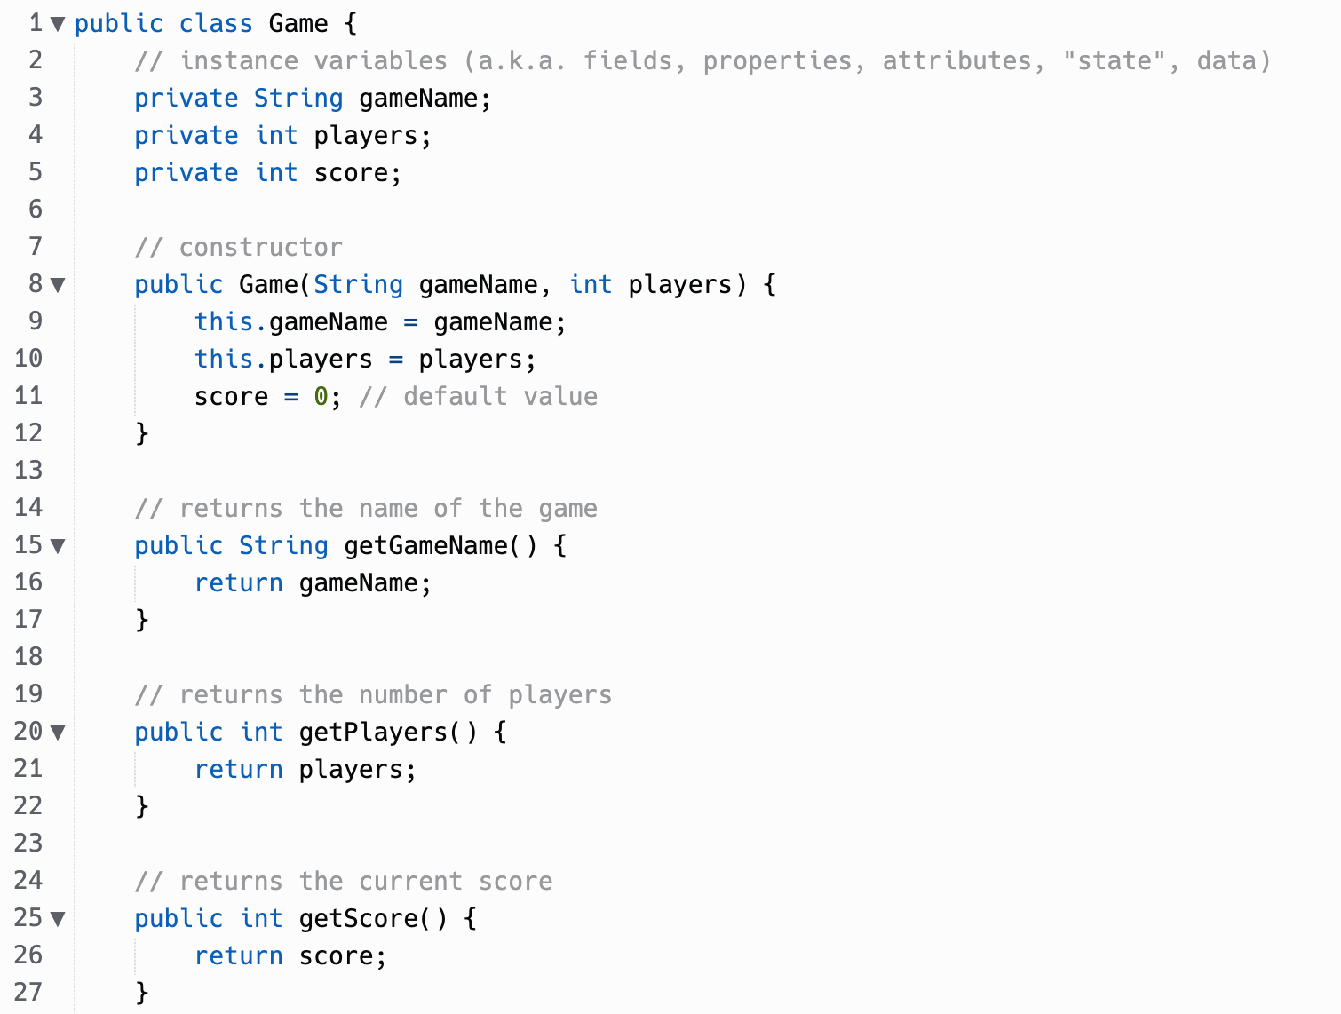

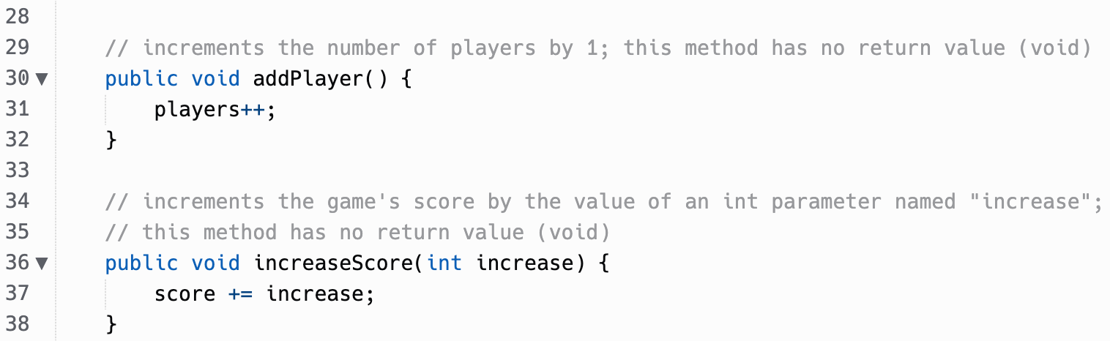

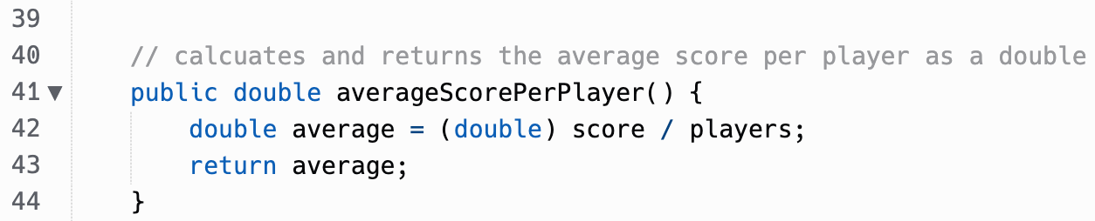

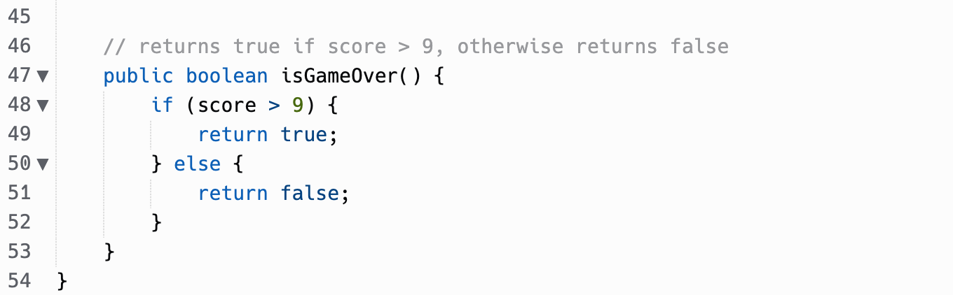

(back)

### Compare (back)

Mr. Miller used “myLetter” as the variable name, but you can use any variable name you want:

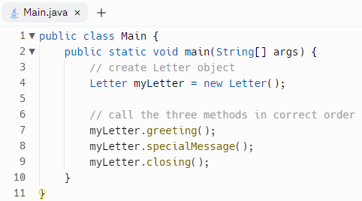

### Sample solution (back)



### Confirm (back)

Three changes are needed, as outlined in steps A, B, and C:



### Sample solution (back)



### Thoughts (back)

When implementing this with a parameter, it makes it possible to use **one single** Letter object (i.e. myLetter) to print multiple letters *to different people from the same person*:

// create Letter object

**Letter myLetter = new Letter("Mr. Miller");**

// write letters to various CSA students!

**myLetter.writeLetter("Abdul");**

System.out.println();

**myLetter.writeLetter("Pritika");**

System.out.println();

**myLetter.writeLetter("Ethan");**

System.out.println();

**myLetter.writeLetter("Lucy");**

If we had instead done it like this:

Letter myLetter = new Letter(**"Mr. Miller", "Abdul"**);

myLetter.writeLetter();

In order to print multiple letters to *different* people, we would need to:

1. Create a new Letter object for every person we want to write a letter to (this is less memory efficient since more objects created → more memory used):

Letter myLetter = new Letter(**"Mr. Miller", "Abdul"**);

myLetter.writeLetter();

Letter myLetter = new Letter(**"Mr. Miller", "Pritika"**);

myLetter.writeLetter();

**etc.**

**OR**

1. Add a setter method to the Letter class so that we could update the toName each time (more lines of code → more error prone!)

Letter myLetter = new Letter(**"Mr. Miller", "Abdul"**);

myLetter.writeLetter();

myLetter.setToName(**"Pritika");**

myLetter.writeLetter();

**etc.**